**Exam details:**  
01. Download all the necessary images by your own from the web (i.e. unsplash, pixels).  
02. Colors and font-sizes is up to you, but choose a sans-serif font.  
03. Design only desktop version, don't need to be responsive to the other devices.  
04. Must declare hover state for every buttons.  
05. You can change the text contents for your website, but it needs to be a cosmetic website.  
06. You have to use the box shadow under the small card contents.  
  
**How to submit:**  
01. Push your code into your github repository and make it public.  
02. Host your website into netlify or github pages.  
03. Now create a doc file in here and paste those two links (github repository link and live site link) including your "Student ID".  
04. Then "Turn In" your file.

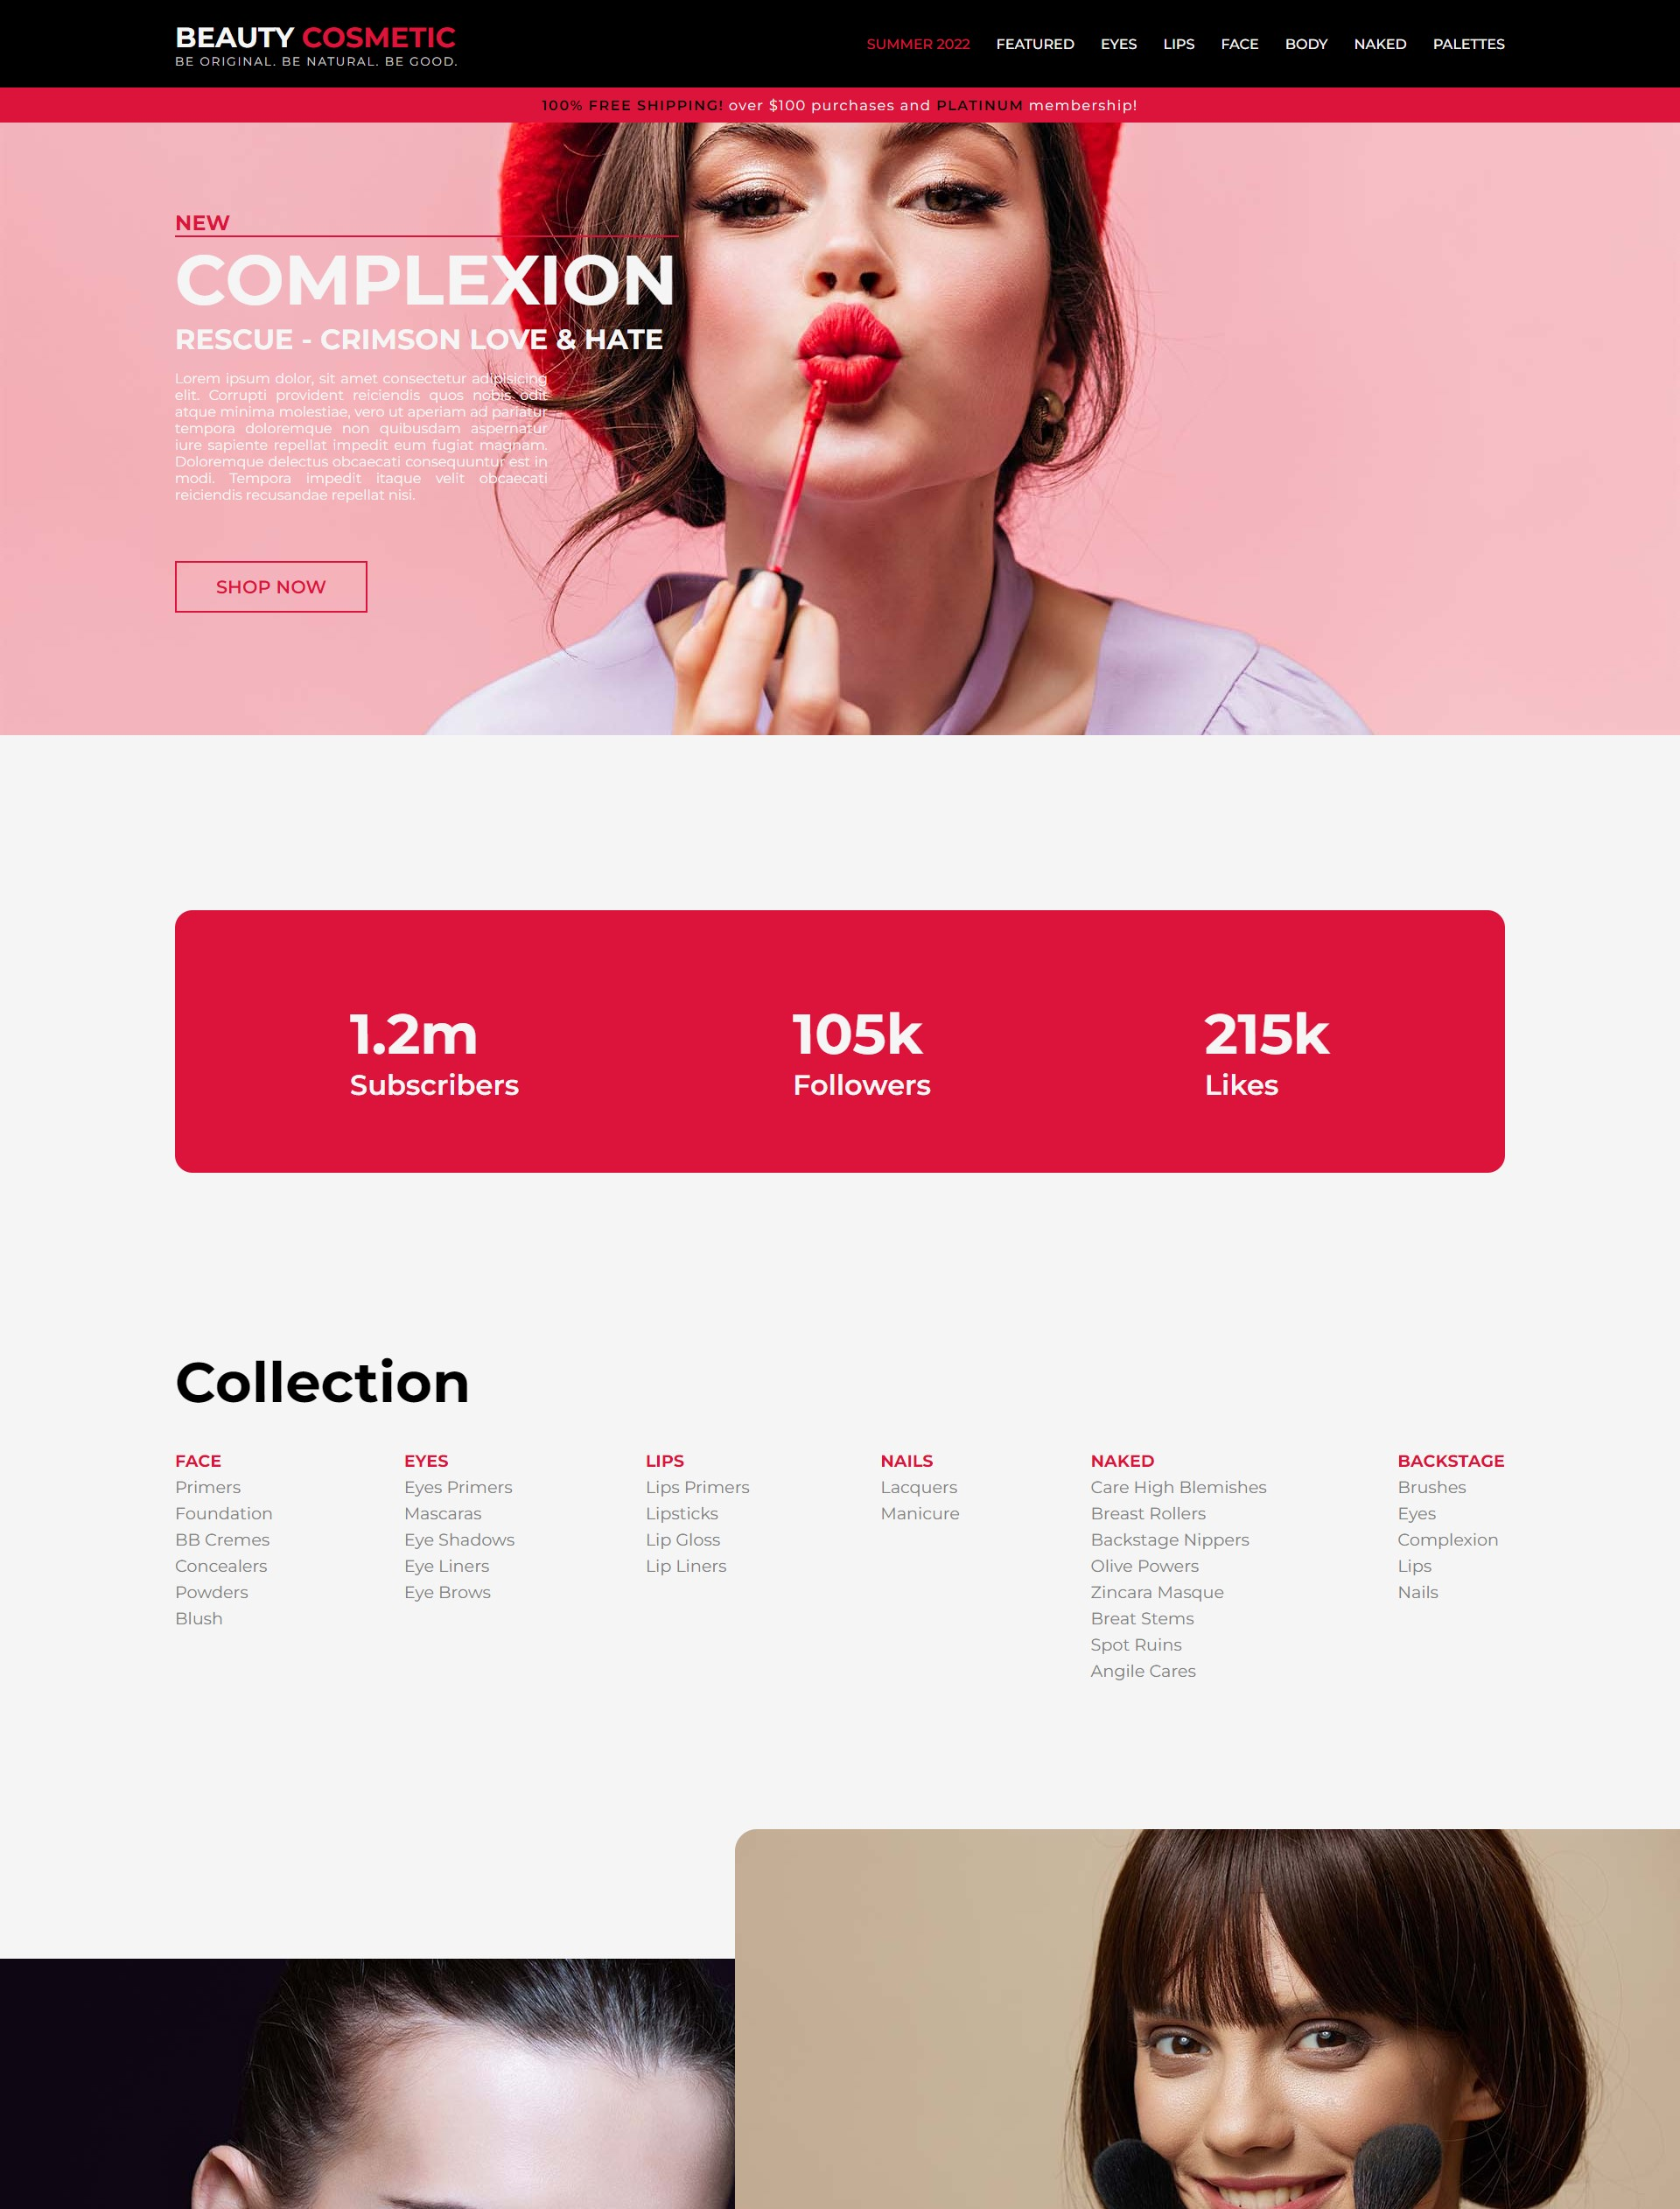

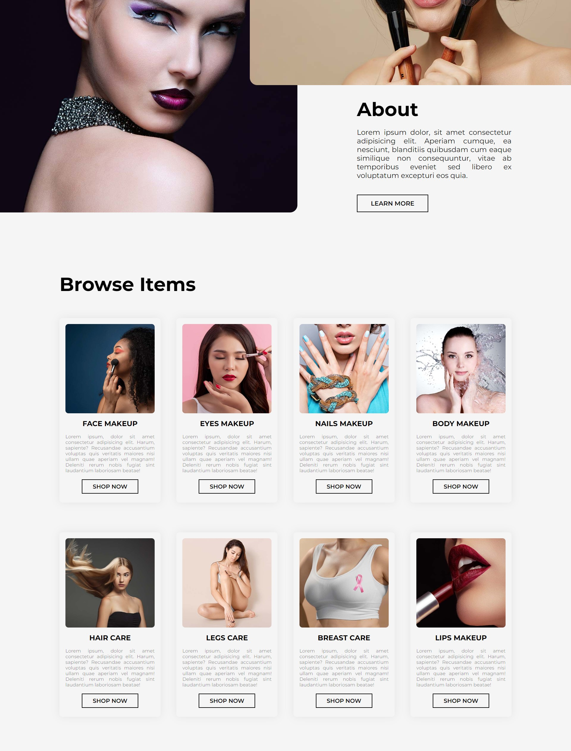

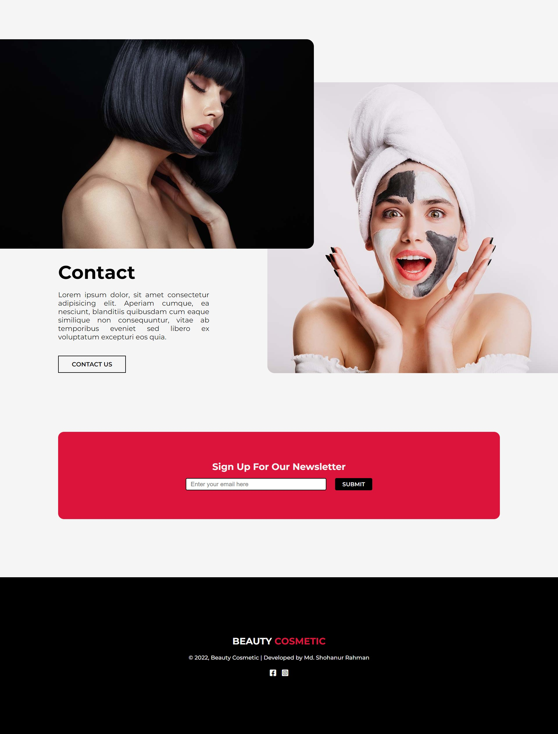

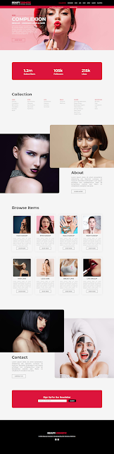

Student ID: 1144